Visual Story- **Rubble**

**what is a visual story**

This Package aims to support people with communication difficulties, learning disabilities, English as a second language and Autistic People. It can be used to help anyone access and understand the play.

**Thank you to TPM’s** 

**Access Sponsor**

**How to Experience Rubble**

**Performances**

**Rubble** runs from February 26-March 18, performance dates and times can be found on our [ticketing page](https://ca.patronbase.com/_TheatrePasseMuraille/Productions/2W/Performances?_ga=2.97321247.1026852163.1672673588-540022601.1605644637). **Rubble** is 90 minutes in length. The theatre space will be open to audiences 30 minutes before the set start time and the Front of House Manager will announce when the theatre is open in the lobby.

**Relaxed Space**

If you leave the theatre at any time there is a Relaxed space in the lobby you can visit. Our Relaxed Space is a quiet space equipped with comfortable seating, blankets, and sensory objects for any patrons who need a break from or would like to experience the performance in a more low-intensity environment.

If you ask an usher they will show you to this area.

**Peer Support Persons** - will be in attendance on:

Thurs Mar 9 - for the 7:30 pm show (from 7pm-10pm)

Sun Mar 12 - for the 2:00 pm show (from 1:30pm-4:30pm)

Fri Mar 17 - for the 7:30 pm show (from 7pm-10pm)

Peer Support People will be available on specific performances to provide one-on-one emotional support if requested. The Peer Support People will be available for participants to talk through any thoughts or emotions that may come up due to the content of the event. They will have mental health resources on hand if further support is needed.

**Performance Advisories & Common questions**

**Are there any performance advisories (loud noises, strobing lights, violence and triggering content)?**

**Content Warnings:** Occupation of Palestine, loss, grief, allusions to stillbirth, torture, abortion, sounds of explosions, depiction of suffocation

**Environmental Warnings (haze? Strobe? Black outs?):** Haze / fog, some very loud explosions, sudden lighting shifts

**Age limit:** Suggested age is 14 (there are no direct depictions of violence, but inferences to beatings, bombings, still birth etc.)

**What access components are there for the performances (ASL, described audio, etc.)?**

All performances will be captioned in English, **except for March 14** (there will be specific seats which will be better to view the captioning from, when you book your tickets please let us know if you will be using the captioning). Where lines from *A State of Siege by Mahmoud Darwish* are spoken in English, Arabic translation will be projected.

**Content Information**

**Plot Details (Spoilers! Continue to the Set section if you do not want to know what happens)**

**Words that are Underlined can be found in the Background section if you would like a definition or would like to learn more.**

Prologue: The Abandoned Theatre

The poet turns on the lights of the abandoned theatre. The actors are onstage.

The poet speaks to the actors and directly to the audience.

The poet tells the actors to tear up their scripts and they do.

Scene 1: Running Orders

Gaza City 2014 (Gaza War). Living room, apartment,

Mo and Noora are watching the Argentina vs. Germany World Cup final.

The phone rings, Leila answers it and puts it on speaker phone. A man named David tells Leila their building has been identified and they have 58 seconds from the end of the call to leave.

Leila tells Mo and Noora they have to run. Mo grabs his prosthesis and says he can't. Leila tells Mo she has got him and tells Noora to run.

We hear an explosion and the sound of falling buildings. Some time passes.

Scene 2: Siege

Leila digging.

Leila tells the audience about the colonization of Palestine by the British in 1917. She talks about her grandmother and grandfather, who were there, and their families. She writes down their names one by one.

Scene 3: The National Poet

The poet/translator introduces himself to the audience as the national poet Mahmoud Darwish and tells us about themself.

Leila and Majide introduce themselves and their children, Mo and Noora.

Leila begins to make coffee. Majide sits alone waiting, restless, trying to read Dostoyevsky.

The poet recites a poem about life and time. The poet then sings a fragment of the song Enta Omry (You are my life) by Om Kalthoum.

Scene 4: Lovers

Majide is alone in his room. He gives up reading, and fiddles with a tape deck.

The poet watches him. The poet begins reciting poetry in Arabic and then continues in English. There is Arabic writing projected.

Leila serves Majide coffee. They take turns reading the grounds for each other. Majide and Leila speak of their love for one another.

Scene 5: Still Birth

We hear sounds of shelling.

Leila gives birth. The sounds of shelling continue.

The baby is blue. Majide holds the baby, and whispers something into his ear. Leila holds the baby. He cries weakly and dies in her arms.

Scene 6: Lovers 2

Leila and Majide are seen separated by a ladder. The poet recites poetry in English and Arabic.

Scene 7: History Lesson 1

The poet, Majide and Leila tell the history of Gaza from 332 AD to present day.

In 332 BC Alexander the Great laid siege to Gaza. Batis of Gaza, a Persian hero, held out in the walled city for 5 months.

Gaza became the “Athens of Asia” until the Romans, in 63 BC, routed the Greeks. They filled the theatre with wresters and boxers.

They were avenged in 66 AD by the Jewish king Alexander Jannaeus. He overthrew the city killing 500 senators…but the Romans return. The Romans become Byzantine Christians.

In 637 the Rashidun caliph, Amr Ibn’al conquers Gaza and, for the first time spares the civilians, their churches, and synagogues.

A period of relative calm and conviviality is broken by King Baldwin the Crusader in 1099 and Saladin in 1187 and Richard the Lionheart in 1191.

The Mongol, Halagu Khan rolls into town in 1260. They stay for 30 years. Azzati survives.

1348 brings plague

1352 floods.

The Ottomans rebuild the small town ushering in the golden age of Radwan Pasha 1556-1690 There are some ‘ethnic tensions.’

Napoleon tries to pluck this emerald on his way to Egypt in 1799. She resists. He leaves a small plague…and a hundred years of solitude.

World war 1

The British mandate.

World war 2.

1948 The Nakba.

Gaza opens her arms to the Palestinian refugees. The 80,000 inhabitants of this coastal strip were joined by more than 200,000 souls cast out by history, and the Zionist brigades.

2002 Our losses: from two martyrs to eight 5 Every day, And ten wounded And twenty homes And fifty olive trees, In addition to the structural defect That will afflict the poem - (*numbers from State of Seige - as tallied by Darwish*)

2014 Operation ‘protective shield’ Takes 44 lives every day Ten children - every day And who can count the wounded? 340 homes 3 schools, and fifty olive trees – every day For 51 days.

Majide calls Gaza the largest prison on earth. The Poet asks: What do you want from me? Leila says to end the siege.

PART TWO:

The Poet recites in both English and Arabic.

Scene 8: Lemons

Leila, Noora and Mo are in the kitchen. Majide enters with lemons.

Leila celebrates and starts planning to make lemon pickle excitedly. She smells sulfur on the lemons and asks Majide where he got them from. Majide says the tunnels. He says they have been open for 6 hours and that he has to go back because they need money and his kind of digging pays. Leila asks him not to go, and Majide says the tunnels are safe when he is there. He leaves.

Leila, Mo and Noora stuff the lemons and put them in jars while the Poet recites.

A distant explosion is heard and Noora breaks a jar.

Scene 9: Majide Is Buried

Majide is trapped in a crawl space that is covered with rubble because the tunnel has collapsed. He digs with his fingers to try and get out. He unearths two silver coins and looks at them. He calls for Leila. He is losing consciousness.

The Poet recites throughout the rest of the scene.

Leila appears above the rubble and listens. Leila asks Majide to wait. Majide says he can’t breathe. He says the Egyptians flooded the tunnels with sewage then explosives. Majide shows Leila the coins. She says they are Greek and were minted in Gaza.

The Poet talks about what it means to resist.

Scene 10: Tryouts

Mo, Leila, Majide and Noora are at home. Mo is hitting the wall with a soccer ball. Noora complains that she needs to study.

Mo tells her he is getting ready to try out for The Al Helal academy. They are sending ten boys aged 9 -14 to Ireland to play football and train and his coach said he could make it on the team. Mo says he is training his left foot and must hit the same spot every day for 1000 touches.

Leila brings out 4 jars and tells him to dribble around them with his left foot only. She tells him it will be better and harder. He does. The room is quiet.

Noora and Majide discuss negative infinity, a mathematical concept. Noora calls it a thing that refuses not to be.

Mo shoots once more at the wall.

Scene 11: Insomnia 1

The Poet tries to sleep but cannot. A mosquito is heard. The Poet tries to kill it, but misses.

There is silence and the Poet says to the mosquito there has been a ceasefire negotiated. The poet tries to sleep but cannot. They begin to write. The words are projected onstage.

The Poet finally kills the mosquito. Explosions are heard; the ceasefire is over.

Scene 12: Insomnia 2/ Riddles

Mo, Majide, Leila and Noora lie sleeping on a mat.

Mo cannot sleep and plays a game telling riddles with Majide. Leila and Noora wake up and join them.

Majide and Noora go back to sleep. Mo stays awake in the dark. Leila fills jars with dust and rubble.

Scene 13: Excavation 1

Majide and Leila are on the beach. Leila has been there all night with Mo, even though there is a curfew. Leila says Mo is fishing on a boat.

Leila digs. Majide is angry that Leila did not tell him about the whereabouts of Mo. He asks her why she is always digging. Leila asks Majide why he is always digging. He says so they can eat.

Leila has been sitting on a statute she pulled out of the sea. She pulls it up to its full height. She says it is Venus Anadyomene. Majide tells Leila to bury her. He says Gaza is no place for a goddess. Leila says Mo won’t leave. Majide says Leila won’t leave. Leila says she is not leaving.

There is an explosion. Majide and Laila cry out for Mo.

Scene 14: Why?

Mo asks why his Lord has forsaken him while he’s still a child.

Leila receives and opens the prosthesis box. She takes it out, looks at it and returns it to its box.

Scene 15: Prosthesis

Mo sits on a bed with a blanket over his legs watching soccer. Leila enters with the prosthesis box. Leila says it is time to try it. They open the box and examine the prosthesis.

Mo asks if he is going to learn how to play soccer with the prosthesis. Leila says yes. Mo says Leila is lousy at football. Leila says but he is not.

Scene 16: Noorah and the intifada/tanks –

Noora faces a tank with a stone and she measures the distance between them.

Scene 17: Helbeh

Noora and Leila make a fenugreek cake using a gas stove and candle light. Noora eats fenugreek seeds throughout the scene.

Noora is pregnant. She does not want to get married or have a child. Leila says Noora ‘has put dirt on the families faces’ (common saying).

Leila pounds cinnamon and cloves and ginger powder and throws them into water. Leila exits. Poet gives it to Noora to drink. Noora continues to eat the seeds.

Scene 18: Majide and the Guard

Majide is inside a cell. He has been tortured.

The guard keeps asking where the tunnels are. Majide refuses to tell him.

Scene 19: Lovers

Leila with Majide’s motionless body. Leila says to cover him.

The Poet and Leila recite a poem about love together.

**THE END**

**The Set**

A bombed and destroyed building, with the colour and texture of cement, there is a ladder in the back right corner and there is a lower section of the stage close to the audience on the right. There is a tall section of wall on the left with an entry/doorway that is rounded and crumpled.

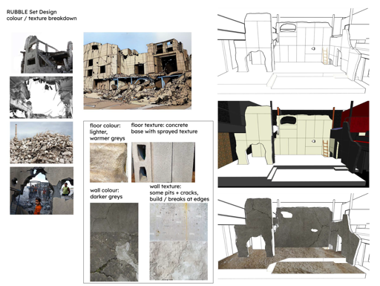

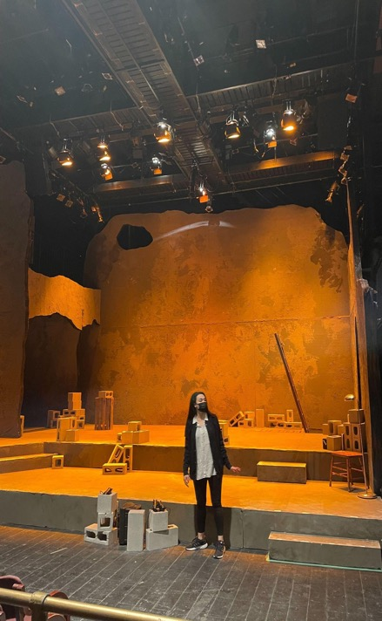

Set Design by Trevor Schwellnus

**Lighting and special effects**

At one point the lights go quite dark. Projection on the set shows poetry.

**The Characters**

###### 

###### 

###### 

###### Lara Arabian | Leila Yousef Kadoura | Mo

###### 40 years old, Mother, Archeologist 12 years old, Son

###### 

###### 

###### 

###### 

###### Sam Khalilieh | Majid Parya Heravi | Noora

###### 40 years old, Father, engineer 16 years old, Daughter

###### 

###### 

###### 

###### 

###### Roula Said | The Poet

**THE END OF THE PERFORMANCE**

You are welcome to come and go from the space while you are at the theatre if you would like to visit the lobby, washroom, or relaxed space.

**Background**

Palestine, located in Western Asia, has 85% of the land illegally seized by Israel since the state was established through the Nakba (Catastrophe) in 1948, which saw the expulsion of more than 700,000 Palestinians from the land. Since then, land-grabbing and Palestinian mass expulsion continued until the Arab-Israeli War broke out in 1967, Israel illegally annexed East Jerusalem and declared it part of its “eternal, undivided” capital, occupying even more land. By 2018, there were 611,000 Israeli settlers living in 250 settlements in the occupied West Bank, including East Jerusalem, in contravention of international law.**[1]**

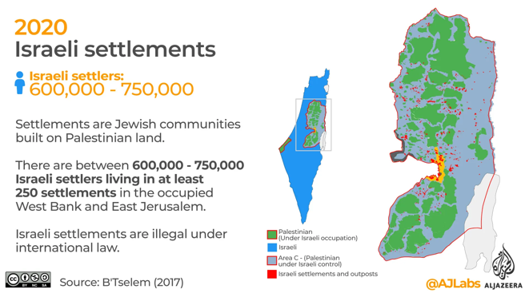

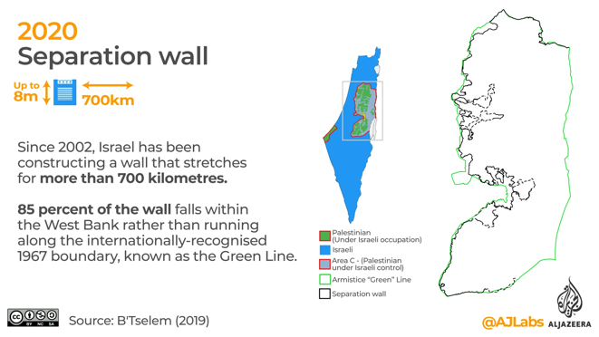

2020- Israeli checkpoints
There is a map with the checkpoints in red, there are 140. Text: There are over 700 road obstacles across the West Bank including 140 checkpoints. These checkpoints severely limit Palestinian movement. About 70,000 Palestinians with Israeli work permits cross these checkpoints in their daily commute. 

The Gaza Strip, a small Palestinian territory that came under Israel's military control, is one of the focal points in the Palestinian occupation. Of the 2 million inhabitants in the small 45km enclave, more than 60 percent of Palestinians in Gaza are refugees, expelled from their homes in other parts of Palestine since 1948. No one can exit Gaza without an Israeli permit since 1991. Starting from June 2007, Israel has been controlling Gaza’s airspace and territorial waters, as well as two of the three border crossing points. The siege has cut off Palestinians from vital services in their main urban centre and has led to the shortage of basic items such as food, electricity, water, and fuel. More than half the population is under 18 years of age, unemployed, and living under the poverty line. Over the years, Israel has launched four protracted military assaults on Gaza. Missile attacks and ground incursions have killed thousands of civilians, and have destroyed people’s homes and infrastructure**[2]**. Humanitarian situation in the Gaza Strip is deeply concerning in the international community.

Israel also maintains apartheid against Palestinians, denying their self-determination by setting laws to limit Palestinians meeting in groups, visiting families in neighbouring villages, and exercising collective rights. In May 2021, Palestinian families in Sheikh Jarrah, a neighbourhood in occupied East Jerusalem, began protesting against Israel’s plan to forcibly evict them from their homes to make way for Jewish settlers. Inspired by the protest, thousands of Palestinians across Israel and the Occupied Palestinian Territories (OPT) held their own protests in support of the families, and against their shared experience of fragmentation, dispossession, and segregation. These were met with excessive and deadly force by Israeli authorities with thousands injured, arrested and detained.[3]

Dostoyevsky: Fyodor Mikhailovich Dostoevsky, sometimes transliterated as Dostoyevsky, was a Russian novelist, short story writer, essayist and journalist.

Om Kalthoum: Umm Kulthum was an Egyptian singer, songwriter, and film actress active from the 1920s to the 1970s. She was given the honorific title "Kawkab el-charq". She is considered a national icon in her native Egypt; she has been dubbed "The Voice of Egypt", the "Lady of Arabic Song" and "Egypt's Fourth Pyramid".

Imkhalal Laimoun: Hot stuffed pickled lemons, best to use small thin skinned lemons. The recipe calls for lemons, filfil mat’houn (red chili paste), nigella seeds, olive oil, crushed safflower threads, salt, water. Lemons are boiled, stuffed and stored in jars.

Nakba: Nakba, the “catastrophe” in Arabic, took place in Palestine in 1948.

In which more than 750,000 Palestinians were forcefully displaced from their homes and pushed into refugee camps in East Jerusalem, the West Bank, the Gaza Strip and neighbouring countries.

https://www.youtube.com/watch?v=megzzpTWajg&t=14s

1948- Palestinians expelled 
There is a map with arrows leading out of Historic Palestine into Gaza, surrounding countries and the West Bank. Text: Zionist military forces expelled at least 750,000 Palestinians and captured 78 percent of historic Palestine. The remaining 22 percent was divide into the West Bank and Gaza Strip. 

Negative Infinity: Infinity is a concept of endlessness, and can be used to represent numbers going on forever. Negative infinity is the opposite of (positive) infinity, negative numbers going on forever.

(<https://support.khanacademy.org/hc/en-us/community/posts/115005794547-What-does-mean-negative-infinity->)

Venus Anadyomene: a representation of the goddess Venus/Aphrodite

Fenugreek Cake: Helba, which literally translates to 'fenugreek,' is a sweet, rich, and sticky Palestinian cake made with fenugreek seeds, semolina, and olive oil. The nutty seeds are simmered away until tender and then kneaded into the dough along with the water infused with their flavor.

<https://hanadykitchen.com/2017/01/15/helba-fenugreek-cake/#:~:text=Helba%2C%20which%20literally%20translates%20to,water%20infused%20with%20their%20flavor.>

**Venue Guide**

Click [**HERE**](https://www.passemuraille.ca/wp/wp-content/uploads/2021/02/TPM-Visual-Story-2020.21-Season.pdf) for more details, including maps, parking information, FAQs, and venue details.

1. <https://interactive.aljazeera.com/aje/2017/50-years-illegal-settlements/index.html>
2. <https://www.aljazeera.com/news/2021/3/14/a-guide-to-the-gaza-strip>
3. <https://www.amnesty.org/en/latest/campaigns/2022/02/israels-system-of-apartheid/>