Visual Story- Trace
Trace will have a relaxed run, designed to welcome audience members and their families who could benefit from a more relaxed environment, including Autistic and neurodivergent patrons. The set-up includes: a pre-show introduction to the play, a very low level house light in the audience, the ability for anyone to come and go from the space, and a relaxed space outside the theatre.

what is a visual story
This Package aims to support people with communication difficulties, learning disabilities, English as a second language and Autistic People. It can be used to help anyone access and understand the play.


Thank you to TPM’s
Access Sponsor

How to Experience Trace
Performances
Trace runs from April 21-30, performance dates and times can be found on our ticketing page. Trace is 75 minutes in length. The theatre space will be open to audiences 30 minutes before the set start time and the Front of House Manager will announce when the theatre is open in the lobby.
Relaxed Space
If you leave the theatre at any time there is a Relaxed space in the lobby you can visit. Our Relaxed Space is a quiet space equipped with comfortable seating, blankets, and sensory objects for any patrons who need a break from or would like to experience the performance in a more low-intensity environment.
If you ask an usher they will show you to this area.
Performance Advisories & Common questions
Are there any performance advisories (loud noises, strobing lights, violence and triggering content)?
Content Warnings: At times throughout the one-hour show, the sound is loud. There are some pulsing and some flashing white Lights.
Environmental Warnings (haze? Strobe? Black outs?): Sound in the show comes from 18 Speakers positioned around the theatre.
Age limit: Any Age
What access components are there for the performances (ASL, described audio, etc.)?
All performances of Trace will be Blind Friendly. Blind Friendly performances have been imagined with audiences who are Blind or have low vision in mind.
Theatre Guides will be available on:
Saturday, April 22, 2023 – 2pm
Sunday, April 23, 2023 – 2pm
Saturday, April 29, 2023 – 2pm
Theatre Guides are not trained Audio Describers, but are trained as Theatre Guides who will Lead you through the show experience and describe visual parts of the show.
If you cannot make one of the three Theatre Guide Performances please let us know when you book your ticket(s), and we can schedule you a Theatre Guide to support you at any of the other performances. You can call the Box Office and request a guide at: 416-504-7529 or email Jenn at: jenns@passemuraille.on.ca
All performances of Trace will be Relaxed Performances. Relaxed Performances are designed to welcome audience members and their families who could benefit from a more relaxed environment, including Autistic and neurodivergent patrons. Find out more about Relaxed Performances.

Content Information
Plot Details (Spoilers! Continue to the Set section if you do not want to know what happens)
Words that are Underlined can be found in the Background section if you would like a definition or would like to learn more.

Pre-show (30 minutes before the show starts): GENDER STORIES
Spectators are invited to move around and listen to different speakers or to record their voices in the recording huts.

CAN YOU HEAR ME
A video showing lake with vocal visualizer
A video of a high soprano ending video footage

TRANSITION TRACK: I AM SAILING (high)
Three new choir members enter when we start to hear I Am Sailing words

BOYCHOIR OF LESBOS
Through the house speakers we hear applause and whistling as a video featuring the Boychoir of Lesbos is projected across various screens and the boys.

CAN YOU HEAR ME: REPRISE
A video showing possible faint echo of Can You Hear Me light motif of water and vocalization

TRISTAN’S MONOLOGUE: PART I
A video showing Tristan is projected from the camera to the screens. Tristan talks about his past, the time that he was being born, his name and explains the word ‘TRANS-FLASH’. He talks about his experiences of other people questioning his change of sex. The show is ‘trans-plaining’ everything in graphic detail by experimental sound art, archival video projections, and live performance.
Tristan comes out of his Hut to introduce the speakers. He welcomes everyone to Trace and speakers (which are called The Yorkville YSM 5s). All of the sounds from these speakers are created by the human voice, Tristan’s voice, all of the voices are his or have been his at some point in his life.

VOICE STORIES
Video fragments and close-ups from the 1997 production of Lord of the Flies.

Tristan lipsyncs. Introducing himself as the headboy of Boychoir of Lesbos.

When voice breaks, tracks change to Between the Shores music/more anxiety.

VOICE STORIES: Part 2
Video section from Lord of the Flies with visualized sound layered on top

MONOLOGUE: Part 2
Video of a live feed from phone to come first then to camera with a sound of low rocking. Tristan turns on his live feed and enters one of the Huts to explain how the sound recording stations work and to show the audience the instructions and the recorders.
He invites the audience to go inside the Huts and their recordings will be added to the show later. This is optional, you do not have to take part.
Video of a live feed from a camera. Tristan describes himself as a transgender worrier rather than a transgender warrior. However, his worries have changed over time. He used to worry about how his transgender identity will affect his daily life. Now he worries about his life and being an average man.

UMS, THIS IS TRISTAN
A video of black and white jump cut shapes and lines.

PENULTIMATE
Tristan tries to sing harmony with himself and struggles. Eventually, he succeeds.
As he does this he adjusts the direction of the speakers.

MONOLOGUE: PART 3
Tristan talks about his experience in Reykjavik during a layover to London. He went to a shop selling men’s dress clothes and he met Yoda. He bought a suit there. He tried to go back to the shop later but the shop was gone by then.

PRE-FULL FATHOM MUSIC
A video of water.

FULL FATHOM FIVE
Choir sings on the catwalk

GHOSTS
A video of a watery world.
Tristan introduces himself again and the Epic Choir of Traceland.
Tristan and the Epic Choir of Traceland sing I’M SAILING AWAY by Styx.

THE END

The Set & Audience Interaction
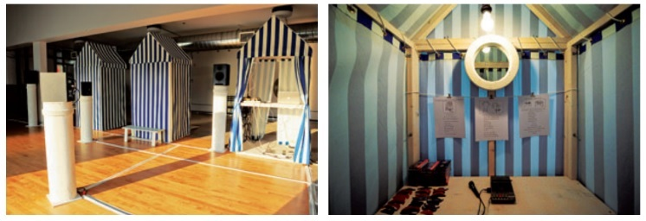
collapsible beach huts
18 plinths with speakers on top
Beach chairs
The set of Trace (inspired by the Visconti film Death in Venice) consists of blue and white striped beach changing huts, audio speakers mounted on specially designed plinths, several folding beach chairs, and a video of the ocean projected (from multiple places) onto the plinths, the huts, and walls—as well as the performer and the audience.
The audio component of Trace is a series of original compositions made from manipulated archival recordings of Tristan’s own singing and speaking voice at different stages (child, teenager, female adult, male adult, and transitional year). These pre-mixed compositions, mostly single tracks, are mixed live into a multi-track soundscape using an original computer interface (conceived by King and Whiston and implemented by Dafydd Hughes) that allows individual tracks to be directed to any one of ten speakers positioned throughout the space.
30 minutes before the performance and 30 minutes after there are opportunities for the audience to engage with the environment and technology. Spectators enjoy a self-directed interactive experience by moving freely around the space picking up different components of the fractured narrative. Two of the beach huts are fully interactive ‘stations’ wherein audience members record, manipulate and reflect on their own voices and identity prompted by instructions to complete and record sentences (for example: Who would I be if..., and When I told them that...). Fragments of these recordings are then mixed live into the ongoing soundscape that comprises the central element of the installation aspect of the work.
Lighting and special effects
-Natural daylight/general lighting
-Small lights for inside booths
-There are 2 projection surfaces which will have projections that are abstract not literal.
The Characters
Tristan R. Whiston plays himself. And the members of The Epic Choir of Traceland are:
Arin Klein
Annanda DeSilva
Celina Carroll
Eli Holliday
Gehan Udayanga
Isabella Cavalheiro-Chin
Kay Jones
Megan Wilk
Nigel Wynne
Riley Kelk
Theo Ryan
Van Ward
Wy Joung Kou
Zena Lord

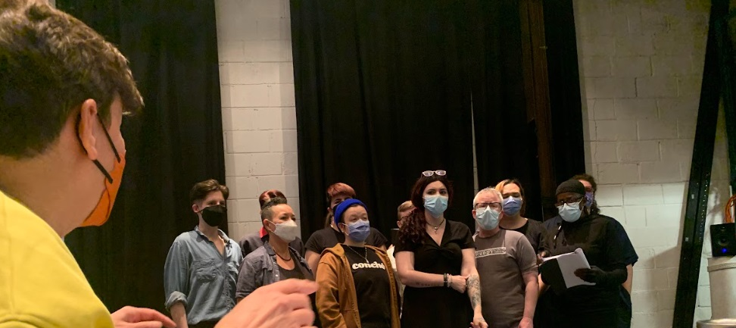
THE END OF THE PERFORMANCE
For 30 minutes you are welcome to explore the booths and make your recordings (instructions in the show and in the booths). You are welcome to come and go from the space while you are at the theatre if you would like to visit the lobby, washroom, or relaxed space.
Background
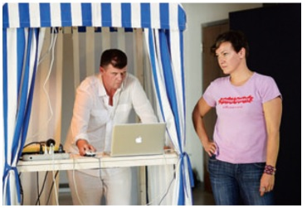
About the Creators:
Moynan King and Tristan R. Whiston are artists with distinct multi-disciplinary practices. Their shared interest in ideas of identity, gender, communication, and the element of time (in both life and art) brought them together as artistic collaborators early in their careers. Since their last collaboration, The Boychoir of Lesbos (1996–2006), they have each continued to expand the scope of their practices with Whiston’s growing skill and interest in new communication platforms such as radio, sound composition and community art, and King’s extensive work in interactive and multi-disciplinary performance. In this collaboration, King and Whiston have created a new work to inspire a living exchange between artist and audience.
About the show: Trace – a sign, such as a footprint, that remains behind to show the former presence of a person or thing no longer; a physical sign of the passage of a person Tristan R. Whiston was born female. For many years, he was seen (and heard) as a woman. Now, after ‘transitioning’ from female to male, he is seen (and heard) as a man. Only a few tangible traces of his ‘past’ remain: photographs, a birth certificate, an ‘F’ on his driver’s license, and numerous archival recordings of his singing voice. Since transitioning from female to male, Whiston’s voice and appearance have become more “in sync” while, simultaneously, his experience in the world has become more fragmented. Trace, though inspired by personal experience, is not “transgender 101”; instead, it seeks to transform a private story into a universal experience where audiences find multiple points of connection. Trace puts the audience at its centre, and asks: how does any person reconcile all of who they have been, with who they are now, and with who they are yet to become; trace explores the idea that stasis is counter to life, and that we are all always ‘becoming.’

TRANS-FLASH –
-term present in the play meaning the comment relates to a Trans past that the person who you are talking to has no idea about:
“Like, Transflash – In The Sound of Music: I played Mother Abbess!

It’s like warning: the following comment may contain explicit reference to a past you know nothing about”

Venue Guide
Click HERE for more details, including maps, parking information, FAQs, and venue details.

