Access Guide:
Through the Eyes of God

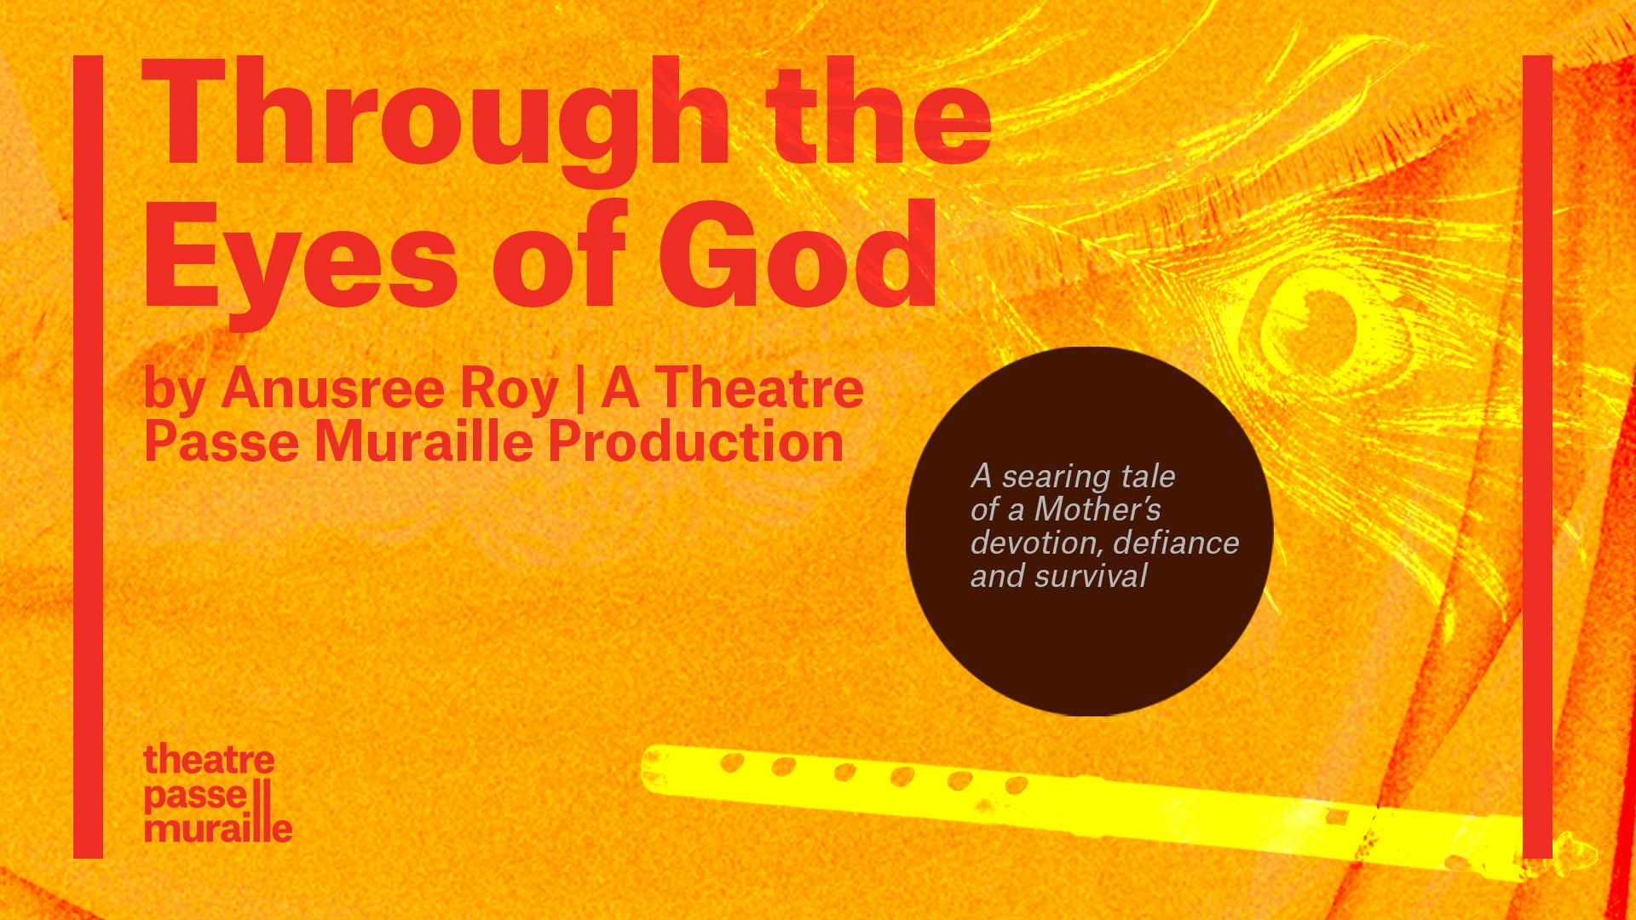
Image description: A peacock feather and flute on a textured orange background with two red vertical lines on either side of the image. Text: “Through the Eyes of God by Anusree Roy | A Theatre Passe Muraille Production”. In a dark circle: “A searing tale of a Mother’s devotion, defiance and survival”. There is a TPM logo on the bottom left corner.
Graphic design by Emily Jung

Theatre Passe Muraille’s Relaxed Environment

Through the Eyes of God will be performed at Theatre Passe Muraille as a Relaxed Environment. A Relaxed Environment is designed to create a more welcoming atmosphere for all audience members, including those who could specifically benefit from a more informal approach, and a ‘relaxing’ of formal theatre conventions.

A Relaxed Environment includes:

At the theatre:
- A very low-level house light in the audience
- the ability for anyone to come and go from the space, get up and move, as needed
- Ability to leave your phone on silent or vibrate
- A more open approach to audience movement or sound
- May also include a quiet space to sit
- May also include a Peer Support facilitator on select days

This Access Guide, that includes:
- An introduction to the play and some of the key elements
- Specific environmental, content and trigger warnings


Thank you to TPM’s Access Sponsor

What’s Included in this Access Guide?
This information package aims to help anyone access and understand the play. In particular, the guide may assist those who have different needs for communication including, but not exclusively, Autistic People, those who communicate using multiple languages, as well as others who may be challenged by some theatrical constructs.

How to Experience Through the Eyes of God Page 4
Performance Advisories & Common Questions Page 4
What access components are available during the performance run? Page 5
Plot Details Page 5
Background Information Page 8
Set Details Page 8
Seating Conditions Page 9
Characters Page 10
The End of the Performance Page 10
Venue Guide Page 10

Need More Information?

If you require more information please reach out to Theatre Passe Muraille’s General Manager Jenn Sartor at jenns@passemuraille.ca.

How to Experience Through the Eyes of God
Through the Eyes of God runs from February 1st-February 21st, 2026 and performance dates and times can be found on our ticketing page. The run will be in a Relaxed Environment and there are 2 Audio Described Performances during the run. Through the Eyes of God will be performed in one act and will last 60 minutes. The theatre space will be open to audiences 30 minutes before the set start time and the Front-of-House manager will announce when the theatre is open in the lobby.
Audio Description (Closed) by Rebecca Singh of Superior Description Services will be available on Sunday February 8 at 2pm with a Q&A to follow and Wednesday February 11 at 7:30pm.
Relaxed Space - If you leave the theatre at any time there is a Relaxed Space in the lobby you can visit. Our Relaxed Space is a quiet space equipped with comfortable seating, blankets, and sensory objects for any patrons who need a break from the performance or would like to experience it in a more low-intensity environment. If you ask an usher they will show you to this area.
Mask Mandatory Performances - There will be a Mask Mandatory Performance of Through the Eyes of God on Wednesday, February 18th at 7:30pm. For this performance, all patrons will be asked to wear a mask, respirator masks (KFN95/KN95/N95 or better) preferred. If you do not have one with you, we will provide a respirator mask at the theatre.

Performance Advisories & Common Questions
Are there any performance advisories?
Content Warnings: Kidnapping, Police Brutality, Distressed yelling, Violence against women and children, child labour, poverty and hunger.
Environmental Warnings: Low lighting throughout. A flickering lighting effect is used for short periods of time, to imitate the feeling of motion. Sudden loud noises and lighting shifts. Sustained Sound effects. Use of water based Haze throughout.
Age limit suggestion: 12+

What access components are available during the performance run?
There will be Mask Mandatory Performances of Through the Eyes of God on Wednesday, February 18th at 7:30pm. For this performance, all patrons will be asked to wear a mask, respirator mask (KFN95/KN95/N95 or better) preferred. If you do not have one with you, we will provide a respirator mask at the theatre. TPM has four rooftop HVAC units with filters and will have a Coway Airmega 400 Smart Air Purifier running in the space. The Coway Airmega 400 is a true HEPA air purifier, it covers 1'560 sq ft in 30 minutes.
Audio Description (Closed) by Rebecca Singh of Superior Description Services will be available on Sunday February 8 at 2pm with a Q&A to follow and Wednesday February 11 at 7:30pm.

Plot Details
The following section of text contains Plot Details that could be considered spoilers! Please continue to the section titled Set Details if you do not want to know what happens (the end of the plot section is highlighted)!

Words that are underlined can be found in the Background Information section if you would like a definition or would like to learn more.

The show starts with Chaya, the main character, being caught for stealing rice. Chaya is caught by Police Madam, as they interact Police Madam realizes this is not the first time Chaya has been caught for stealing rice. Chaya explains that she is stealing the rice for her 11 year old daughter, and it was only one fistful of rice and should not be arrested. As the conversation continues, Chaya reveals she lives in a slum area, where she and her daughter sleep in a shop at night. As Chaya speaks to the Police Madam, Police Madam makes a realization and brings a CCTV image of missing girls over to Chaya. Chaya’s daughter, and a few other children have been taken by a man that disfigures children so they make more money as beggars.
Chaya is worried about her daughter and wants the police to find her as soon as possible. However, the Police Madam is unable to give specifics for when they will be able to find her child. Chaya reveals her daughter is all she has, as her husband, and father are dead, and her mom has left her. The Police Madam tells Chaya that it will take some time, at least next week or so and gives Chaya her phone number. Before police Madam leaves, Chaya asks her the location of the man that took her Daughter, Police Madam tells her the area, but asks Chaya to let the police do their job.
Worried about her daughter, Chaya runs and runs through the streets. Chaya ends up in front of the shop she sleeps in at night.
Chaya bangs on the door of the shop, it is closed. She calls out to the shop owner asking for her money. Realizing he is not inside the shop, as the door is locked from the outside, and she begins running again.
Chaya runs to the railway station, trying to understand the ticket board, but is unable to as she is illiterate. She asks somebody in the crowd if she is in the correct line. Once at the front of the line, she speaks to Ticket Madam, asking about buying a train ticket. The train ticket costs more than Chaya has. Chaya is eventually able to get a train ticket for half the cash she has and a pure silver box.
Chaya is hungry and eats 7 grains of rice. A young girl watches her and asks for some. Chaya deciles, as it’s for her daughter. The Young Girl’s father owns a cane juice shop and asks if Chaya wants to buy, Chaya declines again as she cannot afford it. The Young Girl sings her Sugar Cane song for chaya and ends up giving Chaya a glass of cane juice for free. Chaya promises she will teach The Young girl’s song to her daughter. Chaya then gets onto her train
Chaya travels on the train, she prays, and sleeps, and looks at the photo of her daughter.
At a phone booth, Chaya calls the Police Madam, but there is no new information to be shared.
Chaya waits in a police station, when she is called she shows Inspector Lulllou Sahib the CCTV image, and explains the situation with her daughter. As the two speak it is apparent Chaya does not know much information about Babla and cannot get help from Inspector Lulllou Sahib. He says he has never heard of Babla she is asking about, and tells her to go back home. Inspector Lulllou Sahib offers Chaya some money to get something to drink.
Chaya is hungry and goes to a noodle stand. The Woman, at the noodle stand, makes Chaya some noodles and the two chat for a little. The Woman asks Chaya why she is in Delhi, Chaya tells her and asks if her child was taken to be disfigured for begging. Chaya asks if The Woman knows the man, and where Chaya can find him. The Woman says everyone in the area knows of this man, Babla, but she could not tell Chaya where to find him. The Woman also informs Chaya that the police should not be trusted, as they take money from Babla.
Days pass as Chaya waits. In this time she calls the police station, and asks people on the streets about her daughter.
Chaya is back chatting with The Woman, she tells her the story of her life. Including that she used to be from an untouchable cast. As The Woman keeps offering for Chaya to work at the brothel, Chaya accuses her of taking a cut from Babla as well. At first The Woman denies it, but then admits she knows where Chaya’s daughter is.
Chaya encounters Babla looking for her daughter. Babla tells Chaya he has removed her daughter's eyes, and he will not give her back. Chaya yells at him to get her daughter, Chaya says she does not want her daughter to go through the same thing she had to, having a child at 11 years old. Babla tells Chaya her daughter gets fed three times a day, that she does not miss Chaya and was told Chaya was dead.
Chaya begs Babla one more time, offering to work for him as well to be with her daughter. Babla accepts, and asks her to recruit other children and disfigure them. Chaya declines, she is unable to hurt another child. Babla says she has to do it, if not he will call the police and she will never see her daughter again. Chaya accepts.
Chaya’s daughter, Krishna plays the flute and Chaya runs towards her. Krishna does not believe she is her mom, as Babla had said her mother died. Chaya feeds Krishna a few grains of rice and Krishna hugs her. Krishna asks if her mom will be taking her back, but she does not want to go as there is food where she is now. Chaya says that they will stay.
The sound of the train disrupts their hug, and Chaya is reminded she needs to start getting new children. Chaya teaches Krishna the sugar cane song from the Young Girl, Chaya sings and Krishna’s flute plays.
END OF PLAY

Background Information
The following words are listed in the Plot Details section with an underline. The following list provides definitions and links if you want to learn more.

CCTV image-Closed-circuit television cameras (CCTV) are cameras used for security and may be placed around homes or businesses and may have motion detection sensors.
Slum Area - is a poor and crowded area of a city.

Sugar Cane Song Lyrics - The song sang by Young Girl to Chaya

“Cut the sugarcane into small, small
pieces. Then cut the skin with a
sharp, sharp knife. Then put it
into that big, big machine, and
then roll, roll, roll. Hey roll,
roll, roll! Just keep roll, roll,
roll!”

“He has removed her daughter's eyes”- Due to the nature of Krishna’s injuries the Actor will be closing her eyes to play Krishna.

Set Details
The Main Floor of the BackSpace theatre:
- There is a black box in the centre as the main playing space.
- Planks are on the walls creating a v shape with the tightest spot towards the back wall.
- The planks have slats between them to mimic various windows.
- There are lights at the bottom of the box, and behind the slats to support scene building.
For details on lighting & sound levels for Through the Eyes of God read the Performance Advisories & Common Questions.

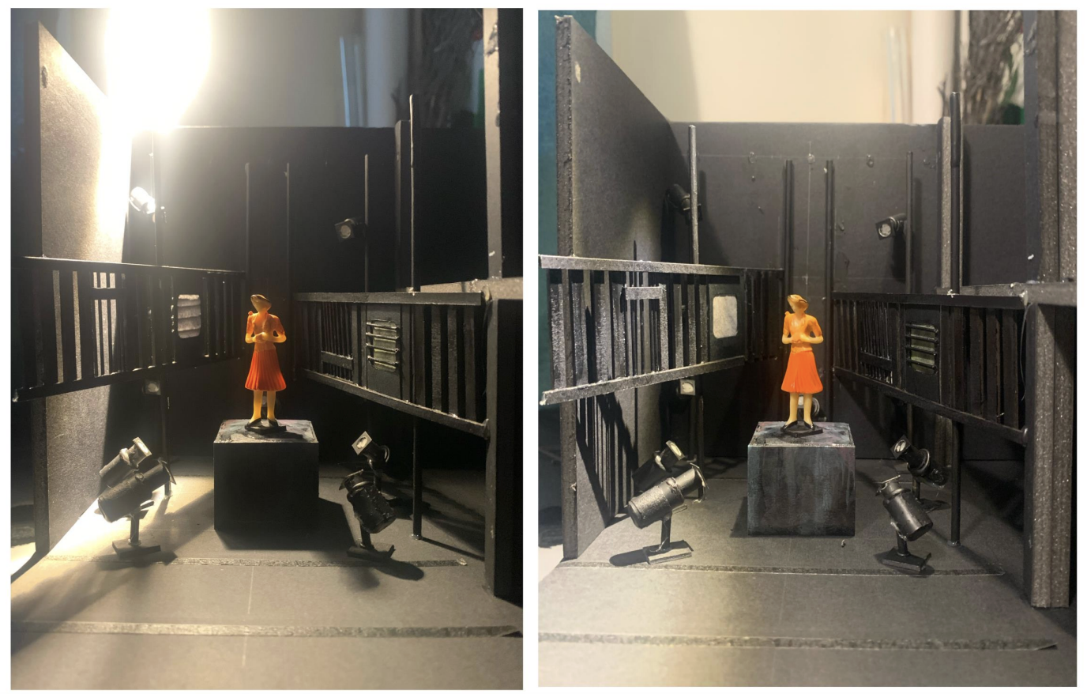
The above picture features a model of the set of Through the Eyes of God as described in the above outline. Set design by Jawon Kang.

Seating Conditions
Through the Eyes of God will be performed with traditional theatre seating with the audience seated together on one side of the playing space. Physically accessible and size inclusive seating is available.

If you have specific seating requests not outlined in this document (and would like this arranged in advance) we invite you to communicate this to our Front House Staff using info@passemuraille.on.ca or by calling 416-504-7529.

Characters
The following descriptions include information about the Characters. All characters are played by one actor
Chaya - Main character, 22 years old, bright face, energetic, twinkle in her eye
Police Madam - 50’s, weathered face, weathered life
Ticket Madam - 30’s, peppy, big bright eyes, big smile
Young Girl - 5, wide blinking eyes, sing-song voice
Inspector Lulllou Sahib - 50s is a big, fat Delhi cop, riddled with eczema on the side of his belly and his elbow that he scratches intermittently.
A Woman - 50s, waddles like a penguin is the chef.
Babla - 40s, tall, chews raw tobacco that’s stuffed between his right cheek and teeth maintains a hard stare.
Krishna - 11, a kid with a bright face

Gabriella Sundar Singh | (She/Her)
This picture features the performer Gabriella Sundar Singh. Gabriella Gabriella is a Tamil Indian and Srilankan artist, born and raised in Toronto. She is a classically trained Bharathanatyam dancer, pianist and singer. You might recognize her as “Chelsea” from CBC’s Kim’s Convenience, or from her work at the Shaw Festival in Niagara-on-the-Lake, where she will be returning for her 8th season in 2026.
During the performance, she will perform all the characters listed above.
Headshot of Gabriella Sundar Singh by David Cooper.

The End of the Performance
At the end of the performance, you are welcome to come and go from the space while you are at the theatre if you would like to visit the lobby, washroom, or Relaxed Space.
Venue Guide
Click HERE for more details, including maps, parking information, FAQs, and the Theatre Passe Muraille Visual story!

